**Week2_TDD Using Junit5 and Mockito_HandsOn**

**Exercise 1: Setting Up JUnit**

Scenario:

You need to set up JUnit in your Java project to start writing unit tests.

Steps:

1. Create a new Java project in your IDE (e.g., IntelliJ IDEA, Eclipse).

2. Add JUnit dependency to your project. If you are using Maven, add the following to your

pom.xml:

<dependency>

<groupId>junit</groupId>

<artifactId>junit</artifactId>

<version>4.13.2</version>

<scope>test</scope>

</dependency>

3. Create a new test class in your project.

**CODE :**

package com.example;

import static org.junit.Assert.*;

import org.junit.Test;

public class CalculatorTest {

@Test

public void testAdd() {

Calculator calc = new Calculator();

*assertEquals*(5, calc.add(2, 3));

}

@Test

public void testMultiply() {

Calculator calc = new Calculator();

*assertEquals*(6, calc.multiply(2, 3));

}

}

**OUTPUT :**

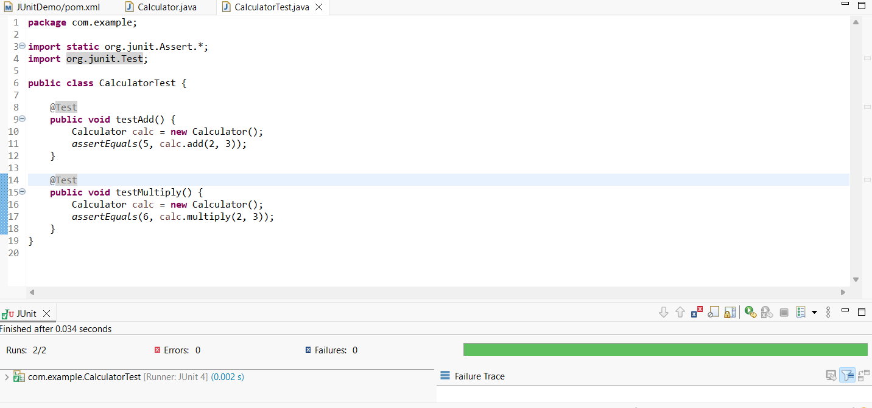

**Exercise 3: Assertions in JUnit**

Scenario:

You need to use different assertions in JUnit to validate your test results.

Steps:

1. Write tests using various JUnit assertions.

Solution Code:

public class AssertionsTest {

@Test

public void testAssertions() {

// Assert equals

assertEquals(5, 2 + 3);

// Assert true

assertTrue(5 > 3);

// Assert false

assertFalse(5 < 3);

// Assert null

assertNull(null);

// Assert not null

assertNotNull(new Object());

}

}

**CODE :**

package com.example.test;

import static org.junit.Assert.*;

import org.junit.Test;

public class AssertionsTest {

@Test

public void testAssertions() {

// Assert equals

*assertEquals*(5, 2 + 3);

// Assert true

*assertTrue*(5 > 3);

// Assert false

*assertFalse*(5 < 3);

// Assert null

*assertNull*(null);

// Assert not null

*assertNotNull*(new Object());

}

}

**OUTPUT :**

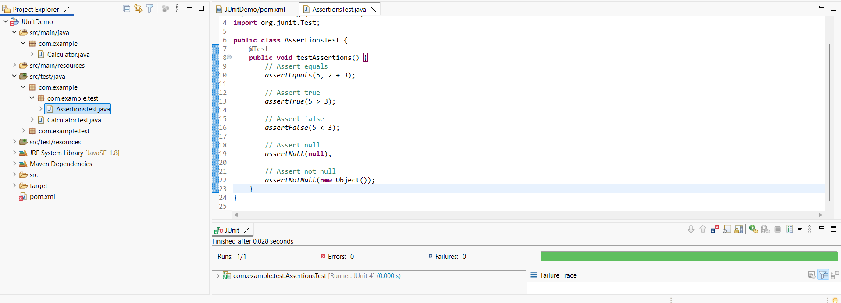

**Exercise 4: Arrange-Act-Assert (AAA) Pattern, Test Fixtures, Setup and**

**Teardown Methods in JUnit**

Scenario:

You need to organize your tests using the Arrange-Act-Assert (AAA) pattern and use setup

and teardown methods.

Steps:

1. Write tests using the AAA pattern.

2. Use @Before and @After annotations for setup and teardown methods.

**CODE :**

Calculator.java

package com.example;

public class Calculator {

public int add(int a, int b) {

return a + b;

}

public int multiply(int a, int b) {

return a * b;

}

}

CalculatorTest.java

package com.example;

import static org.junit.Assert.*;

import org.junit.Before;

import org.junit.After;

import org.junit.Test;

public class CalculatorTest {

private Calculator calculator;

@Before

public void setUp() {

calculator = new Calculator(); // Arrange

System.*out*.println("Setup: Calculator created");

}

@After

public void tearDown() {

System.*out*.println("Teardown: Test finished\n");

}

@Test

public void testAdd() {

// Act

int result = calculator.add(2, 3);

// Assert

*assertEquals*(5, result);

}

@Test

public void testMultiply() {

// Act

int result = calculator.multiply(3, 4);

// Assert

*assertEquals*(12, result);

}

}

**OUTPUT :**

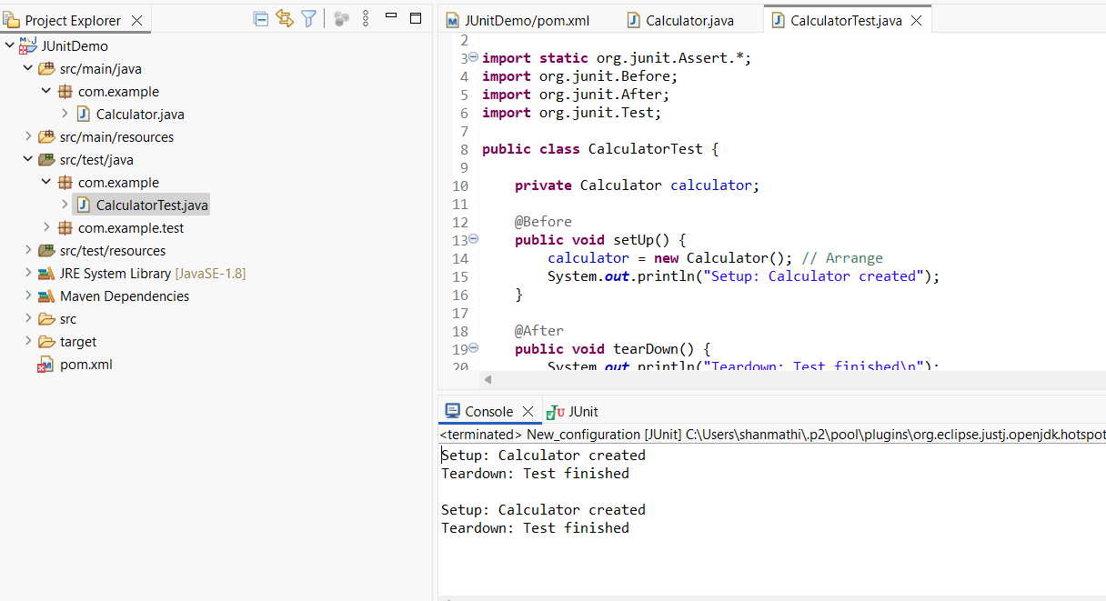

**Exercise 1: Mocking and Stubbing**

Scenario:

You need to test a service that depends on an external API. Use Mockito to mock the

external API and stub its methods.

Steps:

1. Create a mock object for the external API.

2. Stub the methods to return predefined values.

3. Write a test case that uses the mock object.

Solution Code:

import static org.mockito.Mockito.*;

import org.junit.jupiter.api.Test;

import org.mockito.Mockito;

public class MyServiceTest {

@Test

public void testExternalApi() {

ExternalApi mockApi = Mockito.mock(ExternalApi.class);

when(mockApi.getData()).thenReturn("Mock Data");

MyService service = new MyService(mockApi);

String result = service.fetchData();

assertEquals("Mock Data", result);

}

}

**CODE :**

**ExternalApi.java**

package com.example.demo;

public interface ExternalApi {

String getData();

}

**MyService.java**

package com.example.demo

public class MyService {

private ExternalApi externalApi;

public MyService(ExternalApi externalApi) {

this.externalApi = externalApi;

}

public String fetchData() {

return externalApi.getData();

}

}

**MyServiceTest.java**

package com.example.demo;

import static org.junit.jupiter.api.Assertions.*assertEquals*;

import static org.mockito.Mockito.*

import org.junit.jupiter.api.Test;

import org.mockito.Mockito;

public class MyServiceTest {

@Test

public void testExternalApi() {

ExternalApi mockApi = Mockito.*mock*(ExternalApi.class);

*when*(mockApi.getData()).thenReturn("Mock Data");

MyService service = new MyService(mockApi);

String result = service.fetchData();

*assertEquals*("Mock Data", result);

System.*out*.println("Test Passed: " + result);

}

}

**OUTPUT :**

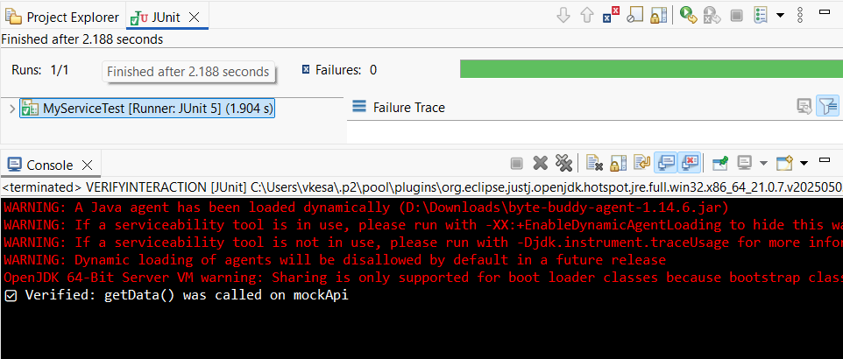

**Exercise 2: Verifying Interactions**

Scenario:

You need to ensure that a method is called with specific arguments.

Steps:

1. Create a mock object.

2. Call the method with specific arguments.

3. Verify the interaction.

Solution Code:

import static org.mockito.Mockito.*;

import org.junit.jupiter.api.Test;

import org.mockito.Mockito;

public class MyServiceTest {

@Test

public void testVerifyInteraction() {

ExternalApi mockApi = Mockito.mock(ExternalApi.class);

MyService service = new MyService(mockApi);

service.fetchData();

verify(mockApi).getData();

}

}

**CODE :**

**ExternalApi.java**

package VERIFYINTERACTION;

public interface ExternalApi {

String getData();

}

**MyService.java**

package VERIFYINTERACTION;

public class MyService {

private ExternalApi externalApi;

public MyService(ExternalApi externalApi) {

this.externalApi = externalApi;

}

public String fetchData() {

return externalApi.getData();

}

}

**MyServiceTest.java**

package VERIFYINTERACTION;

import static org.mockito.Mockito.*;

import org.junit.jupiter.api.Test;

import org.mockito.Mockito;

public class MyServiceTest {

@Test

public void testVerifyInteraction() {

// Step 1: Create a mock object

ExternalApi mockApi = Mockito.*mock*(ExternalApi.class);

// Step 2: Call the method using MyService

MyService service = new MyService(mockApi);

service.fetchData();

// Step 3: Verify that getData() was called

*verify*(mockApi).getData();

System.*out*.println("Verified: getData() was called on mockApi");

}

}

**OUTPUT :**

